STA607: Computational Statistics 1
Student Id: 22424243
Question 1.
Answer:
(a) The crabs data frame has 200 rows and 8 columns, describing 5 morphological measurements on 50 crabs each of two colour forms and both sexes, of the species Leptograpsus variegatus collected at Fremantle, W. Australia.
(b)
data.frame': 200 obs. of 8 variables:
$ sp : Factor w/ 2 levels "B","O": 1 1 1 1 1 1 1 1 1 1 ...
$ sex : Factor w/ 2 levels "F","M": 2 2 2 2 2 2 2 2 2 2 ...
$ index: int 1 2 3 4 5 6 7 8 9 10 ...
$ FL : num 8.1 8.8 9.2 9.6 9.8 10.8 11.1 11.6 11.8 11.8 ...
$ RW : num 6.7 7.7 7.8 7.9 8 9 9.9 9.1 9.6 10.5 ...
$ CL : num 16.1 18.1 19 20.1 20.3 23 23.8 24.5 24.2 25.2 ...
$ CW : num 19 20.8 22.4 23.1 23 26.5 27.1 28.4 27.8 29.3 ...
$ BD : num 7 7.4 7.7 8.2 8.2 9.8 9.8 10.4 9.7 10.3 ...

(c) F M
B 50 50
O 50 50

(d)

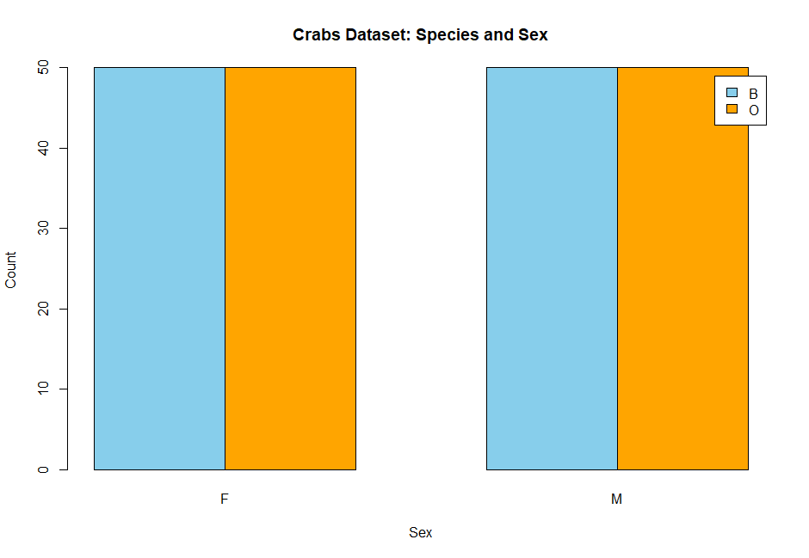
(e) The Crabs dataset is perfectly balanced across the four groups (species and sex).
Each group (Blue Female, Blue Male, Orange Female, Orange Male) has 25 observations.
That means the dataset is balanced, with equal representation across species and sex.
This balance is useful for classification tasks (like discriminant analysis or logistic regression), because it avoids bias toward one group and makes comparisons fairer.
Question 2.
(a)
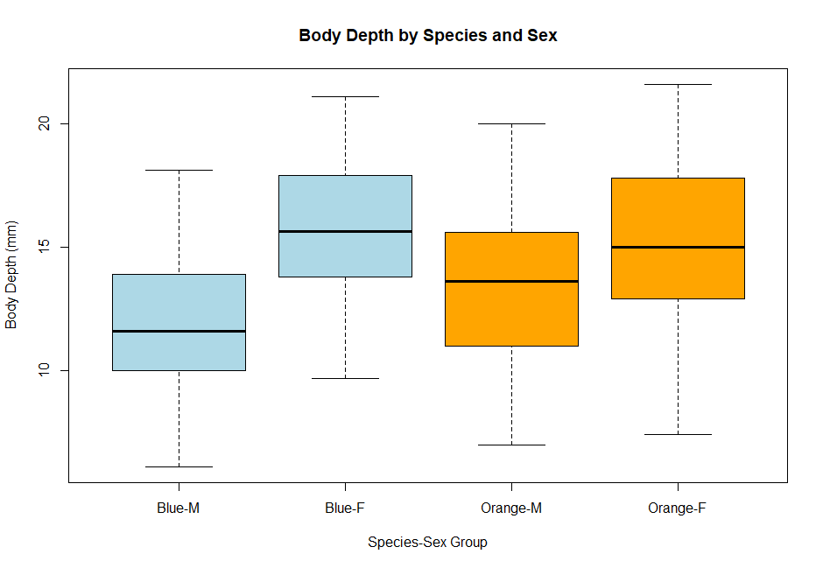
(b)
Outliers
Blue-M: A few outliers appear above the upper whisker, indicating some unusually deep-bodied male blue crabs.
Blue-F: Generally tighter distribution, fewer or no extreme outliers.
Orange-M: Outliers are present, similar to Blue-M, with some crabs showing much larger body depth than the rest.
Orange-F: More compact, with fewer extreme values compared to males.

Central Tendency
Males (both species): Higher median BD than females.
Orange crabs: Medians are slightly higher than Blue crabs, suggesting deeper bodies overall.
Females: Lower medians, more consistent across species.
Variability
Males: Greater variability (larger interquartile range and longer whiskers).
Females: Less variability, distributions are tighter.
Orange-M shows the widest spread, while Blue-F shows the narrowest.

Question 3.
(a)
Answer:
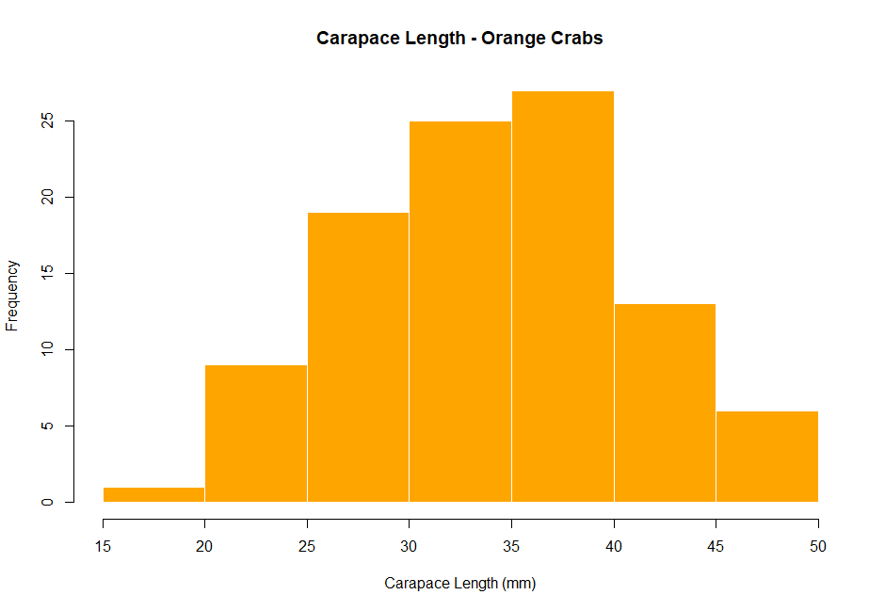

(b) Shape of the Distributions
Blue Crabs (B)
The distribution of CL is fairly symmetric, with most values clustering around the middle range.
It shows a unimodal shape (one clear peak).
There is little evidence of skewness, the tails on both sides are roughly balanced.
Orange Crabs (O).The distribution is also unimodal, centered around a similar range as the blue crabs.
It tends to be slightly right-skewed (longer tail on the higher CL side), meaning a few orange crabs have relatively larger carapace lengths compared to the bulk of the group.

Comparison:
Both species have similar central tendencies (their CL values overlap considerably).
Blue crabs: distribution is tighter and more symmetric.
Orange crabs: distribution shows a bit more variability and a slight skew to the right.
Neither distribution is bimodal,both are unimodal.

